

North South University

Department of Electric and Computer Engineering

Project Proposal

Development of Web Page

Property Buy and Sell Platform

Internet and Web Technology Lab  
CSE482L

Section: 2

Semester: Spring 2022

Student Name and ID Course Faculty

H.M. Basharat Ziad (1721155042) Md. Naqib Imtiaz Hussain

Sumaiya Sharmeen (1731500042)

Ishrat Jahan Prity (1612427042) Lab Instructor

Md Shakil Hossain (1812959642) Farjana Alam

**Abstract**

In today’s world. People are obsessed with internet. Using of internet have increased rapidly and hence. A web page can be used efficiently for business purpose. This project idea is similar to an ecommerce type webpage for a shop. Generally, ecommerce web page targets all kinds of products. But our app only focuses on properties only. With the goal of delivering eye catching yet simplistic websites in terms of user interface our “property deck” webpage can solve many problems.

**Introduction**

The current covid situation has caged us for a long time. And it was the time when people tend to use the internet platforms at an alarming rate. There a very good number of companies that provide the service of buying and selling properties. Most of them serve on the field and can not reach many consumers. So, basically to reach many customers internet is the best platform. A web page can help in many ways. Organizing all information, getting various kind of information in one place, safe data. It is easy to sell items online rather than in market and the cost of seller gets a huge reduction. One of the best parts about it is that you can sell online beyond the borders of your city, your country, or even continent without ever leaving your work desk! Once you get started, virtually anyone from anywhere in the world can become your customer. One question may arise. There are other platforms as well as websites also. The difference from other platforms and webpages is that about the location. Here in the era of internet finding a location is a piece of cake. Motivating other offline property sellers to come forward to use the internet to reach more consumer is the main goal of our web page.

**Front End Plan**

1. Home Page

2. Search result page

3. Buy Property page

4. Sell Property page

5. Property Location page

6. Contact Information page

7. Login/ Register page

**Back End Development**

Account Creating, Password Recover:

1. Sign-up form

2. Login

3. Logout

4. Forget Password

Search Bar: User can use the search bar by inputting two desired letter and the probable match from database will toggle through AJAX.

**User Story**

Use Case 1:

Mr. Rakib (Landowner). He needs to sell his property. He has two options.

Search on our website. This gives him options to sort some best-priced land or house rent in his specified area based on his requirement and some initial idea about the expected price now he may visit our website then register and create a post including his land or house location details.

He may directly contact our admin. Whare 24/7 we are actively working for the customer our expert broker will give him an instant suggestion or step by step guideline.

Use Case 2:

Mr. Rony (a US-based IT worker) wants to buy a farmhouse. But he doesn’t have any trusted relative in Bangladesh. He has two options.

Search in our site with location, and price range. Our site will give him the best search results. Where he may directly contact the landowner.

He may directly contact our admin. We will assign an expert broker who will notify him if any new landowner creates a post and satisfy his requirement.

**Solution Description**

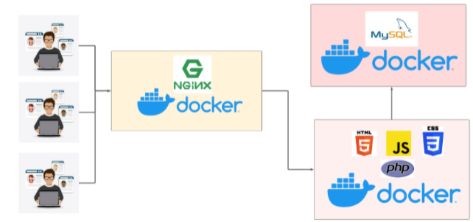

**Docker:** Docker is a set of the platform as service products that use OS-level virtualization to deliver software in packages called containers. The service has both free and premium tiers. The software that hosts the containers is called Docker Engine.

**Nginx:** Nginx, stylized as NGINX, Nginx, or NginX, is a web server that can also be used as a reverse proxy, load balancer, mail proxy, and HTTP cache. The software was created by Igor Sysoev and publicly released in 2004. Nginx is free and open-source software, released under the terms of the 2-clause BSD license.

**Mysql:** MySQL is an open-source relational database management system. Its name is a combination of "My", the name of co-founder Michael Widenius's daughter, and "SQL", the abbreviation for Structured Query Language.

Our Mysql DB will receive requests from your backend PHP client. Our backend client has only access to our MySQL database image.

As you can see in the figure: 8.1 User will request to 8080 port of our docker image and our docker image will redirect the request to our Nginx server. Then Nginx will process the request and route it to our PHP docker image. This image is responsible for both the backend and frontend. This image will talk to the database and Nginx server

**Proposed Timeline**

As we have checkpoints to follow by our lab instructor, we have to follow that.

**Conclusion**

The Universe Is Moving Too Fast and Nobody Knows Why. Keeping the pace and style of living should be maintained. Old ways can be good but an updated ones can be better. Be present in the market talk with people takes time. It can be shortened it can be updated and we have to step forward. Time is money. To a small entrepreneur to a successful one can be obtained with a small change. Now it’s up to oneself.